Sumana Shree C S
1NC22EC106

AutoLead CRM
28 Jun 26

OVERVIEW
AutoLead CRM is a lead management application designed for HSR Motors to simplify the process of managing customer leads from multiple sources such as Facebook, Google Ads, websites, and referrals. The application replaces manual spreadsheet tracking with a centralized system where the sales team can view, search, and update lead information efficiently. It also provides a dashboard for managers to monitor lead status and performance, enabling faster decision-making and better collaboration across the sales team.

FEATURES
- Lead Listing – View all customer leads in a single table with search functionality.
- Lead Details – View complete customer information, lead source, interested vehicle, assigned sales executive, and notes.
- Dashboard – Monitor total leads, new leads, contacted leads, qualified leads, lead sources, and recent activities.
- Search Leads – Quickly find leads using the search bar.
- Lead Status Tracking – Update and monitor lead status such as New, Contacted, Qualified, and Lost.
- Add Lead – Add new customer leads into the system.
- Lead Source Tracking – Track leads received from Facebook, Website, Google Ads, and Referrals.
- Recent Activities – View the latest actions performed by the sales team.

WIREFRAME / MOCKUP / PROTOTYPE

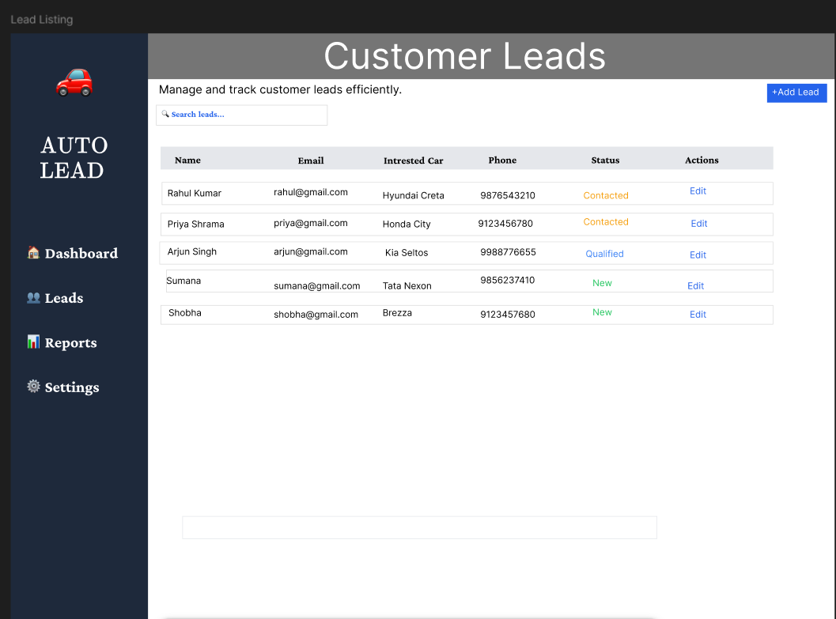

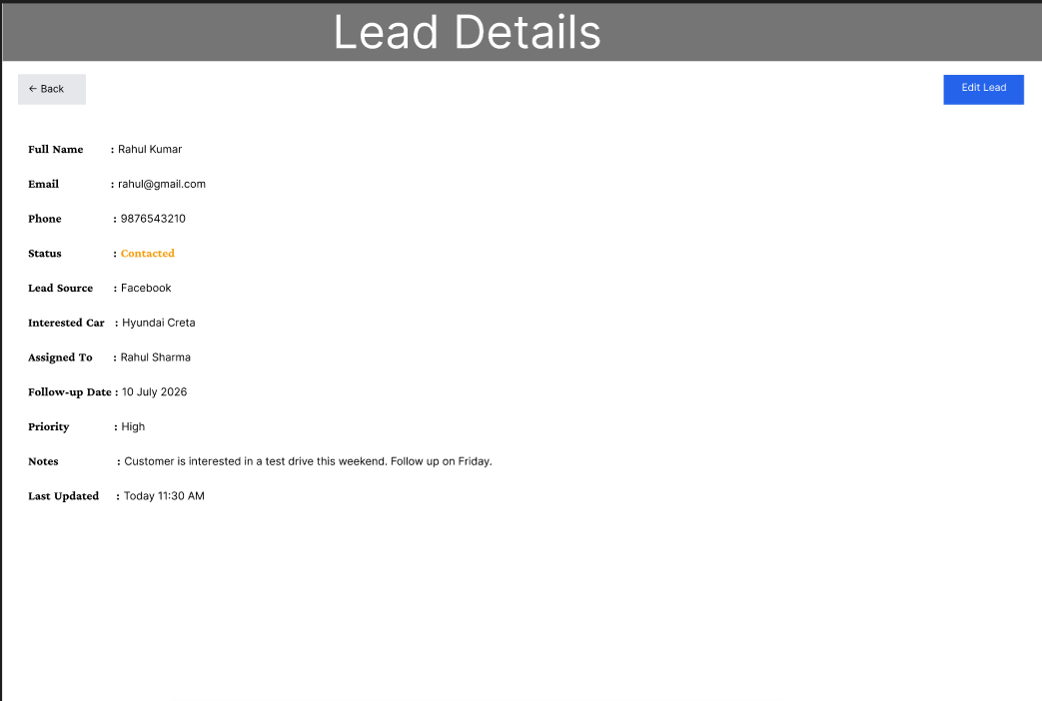

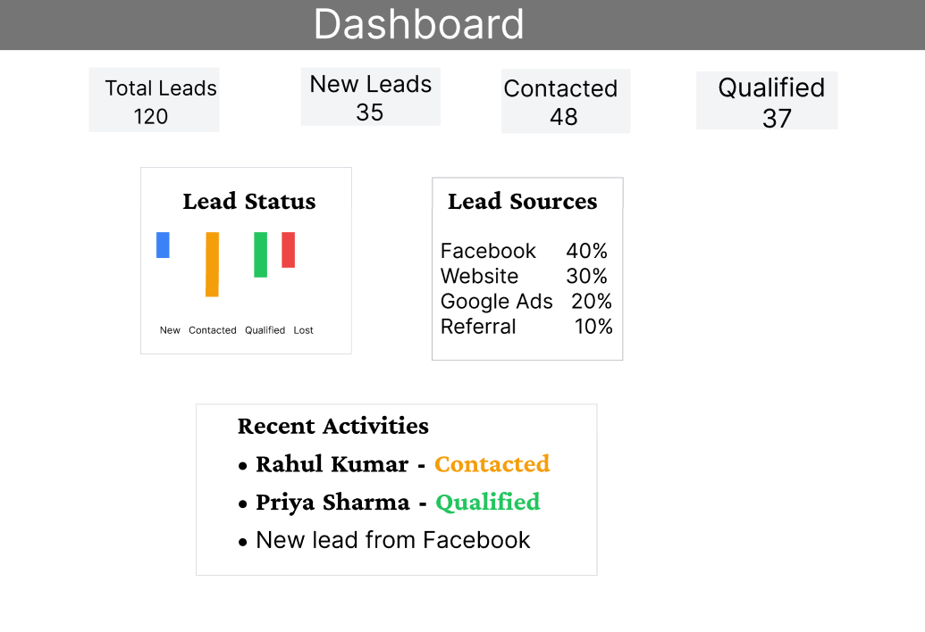

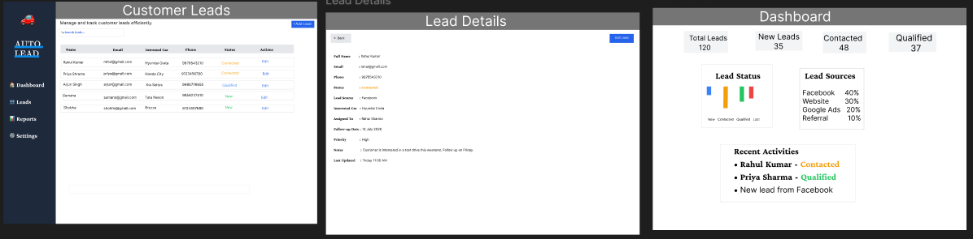

USER FLOW
Application Walk-through
The user logs into AutoLead CRM and is presented with the Lead Listing screen, where all customer leads can be viewed and searched. By selecting a lead or clicking Edit, the user navigates to the Lead Details screen to view or update customer information, lead source, interested vehicle, assigned sales executive, and notes. The Dashboard provides an overview of key business metrics, including total leads, lead status, lead sources, and recent activities, helping managers monitor sales performance and make informed decisions.

OTHER LINKS
https://www.figma.com/design/6134uAsQ8vG1UnPcFD4tH2/AutoLead-CRM?node-id=0-1&t=oooiI0IMvupt3yxj-1x

